NAME = HARSHIT MAROO

REG NO = 22BIT0320

DOMAIN = COMPETETIVE PROGRAMMING

Question 1:

Chef has two strings S1 and S2 both made up of alphabets from the word COOKOFF(C,O,K,F). He wants to know whether he can create any permutation of S1 by joining various permutations of S2 together.

CREATE STRING

APPROACH:

In this we will take two strings as input and find their lengths namely l1 and l2

And then if l2 doesn’t completely divide l1 or l1 less than l2then we will simply

print no else we will sort l1 and l2 and take a count assign to 0 and then iterate

through l1 and if count equals l2 then we will set count 0 and if each character

of first string not equals to the index of s2 count then we will assign result

equals 0 and break so if result is 0 then we will simply print no else we will

simply print yes.

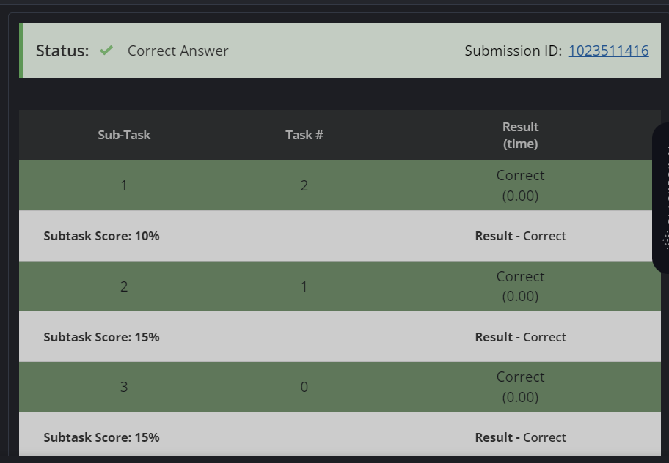

Question 2:

Chef has been given two integers N and K. His task is to choose m positive numbers(A1,A2.....Am) such that N+2^A1+2^A2.......2^Am = K while also minimising the value of m. Help him find the solution.

APPROACH:

First we will take input and then we will take float variable equals 0 and ans

Variable equals 0 and then we will take log of k and assign that value to y

and print ans as y-1

Que

QUESTION 3:

Chef wants to build a staircase. He has ordered blocks of different sizes in order to construct it. He was delivered the stairs separately in a jumbled order. He makes trips using a crane to pick up blocks on the way and stack it. He gets two groups of stairs such that, when placed one after another, a full staircase is made. Order of the sizes of blocks is given in an array. Chef has fuel for maximum two trips. Print whether he can make the staircase or not

Approach :

Firstly by taking input and then we will sort the elements of list and store them

in another list and just take a variable temp equal to 0 and then we will do

nested for loop in wich outer loop will run for two times and inner for loop will

run for the length of the sorted list and iterate it until the list becomes empty

and and if length of sorted list becomes 0 then we will simply print yes and

assign temp to 1 and break and at the end if temp equals 0 then print no else

print yes .

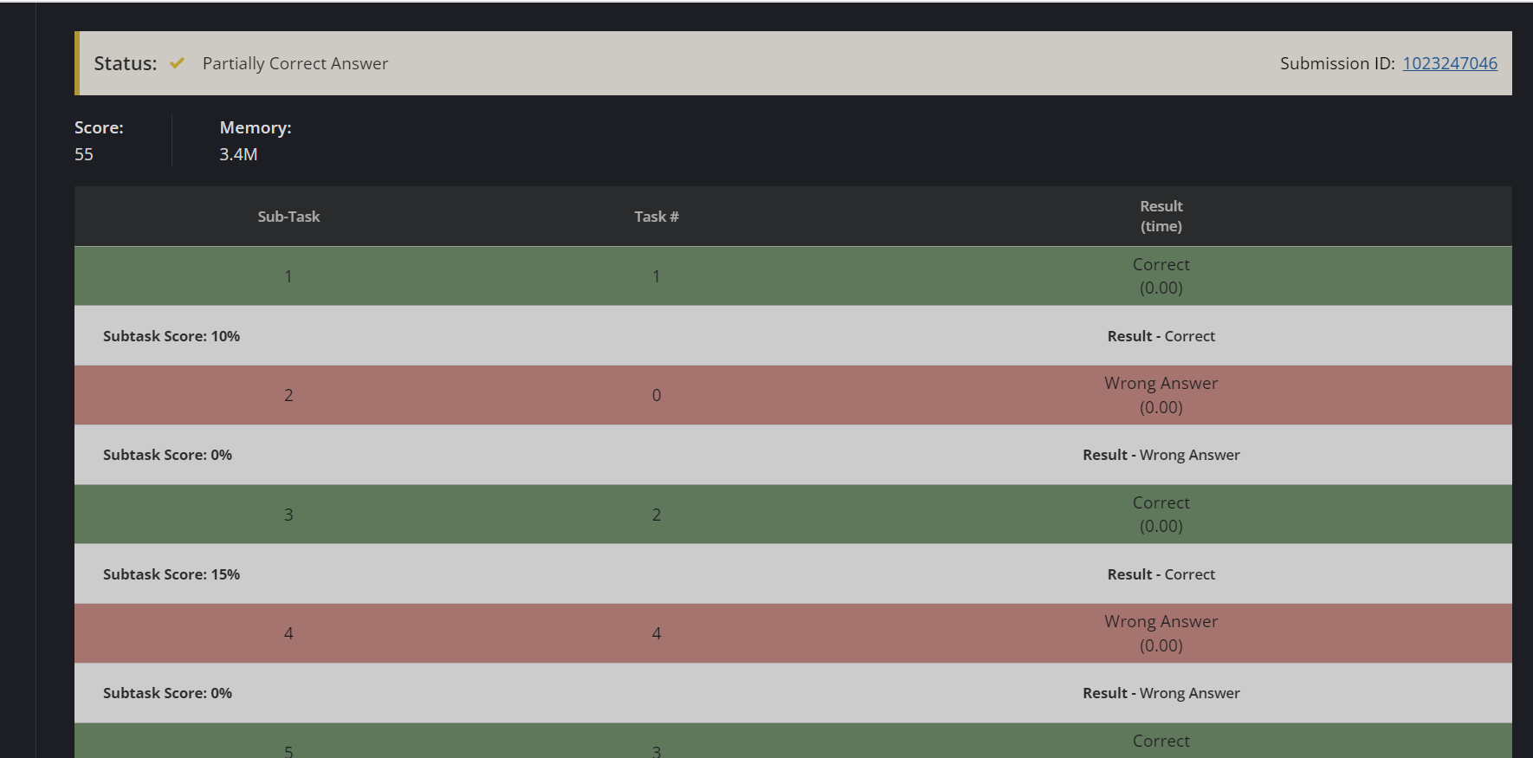

QUESTION 4:

Chef has an array of integers from 1 to N in jumbled order. Chef allows his friend to ask for subsequences of the array as many times as he requires. But, when chef gives the numbers of the subsequence, he gives it in a jumbled order. What is the minimum number of such requests his friend can make to recreate the original array

APPROACH:

In this we will take the input for the test cases and then we will find the log of

that value and then the ceil value that will be our answer.

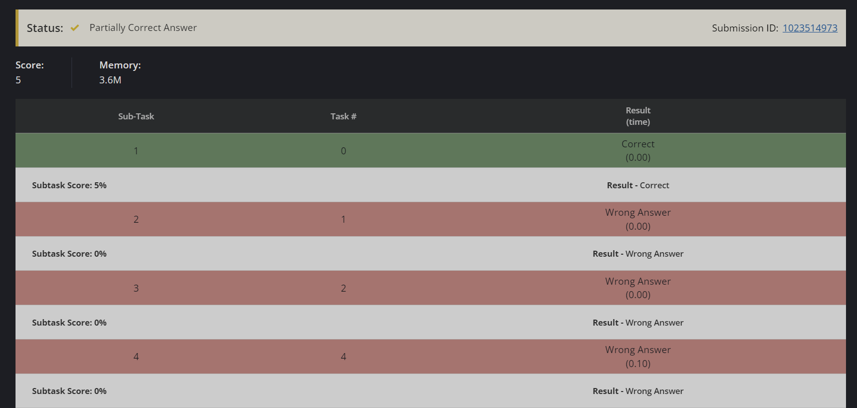

QUESTION 5:

There are n islands for which X and Y coordinates are given. Chef, being a greedy ruler wants to conquer them all. The cost to conquer each island is K. However, when chef conquers island, he can connect them using bridges. When an island can be surrounded by other island and its bridges completely, conquering the island becomes easier. The cost to conquer now gets divided by a constant C. Chef wants to spend the least and conquer all the island. Find the minimum amount he will have to spend to conquer every island optimally.

APPROACH:

Actually in this question I don’t get a good approach but I just calculated the

floor value of the answer that I get by multiplying the input values K and C.

QUESTION 6:

APPROACH:

In this firstly we will take input and then we will atke a count variable assign to

0 and then we will take the input of all the elements of the array and then we

will do nested for loops and we will chech if aof I + aof j equals sum and aof I ^

aof j equals xor then we will increament the count by 1 and then we will simply

print the count .

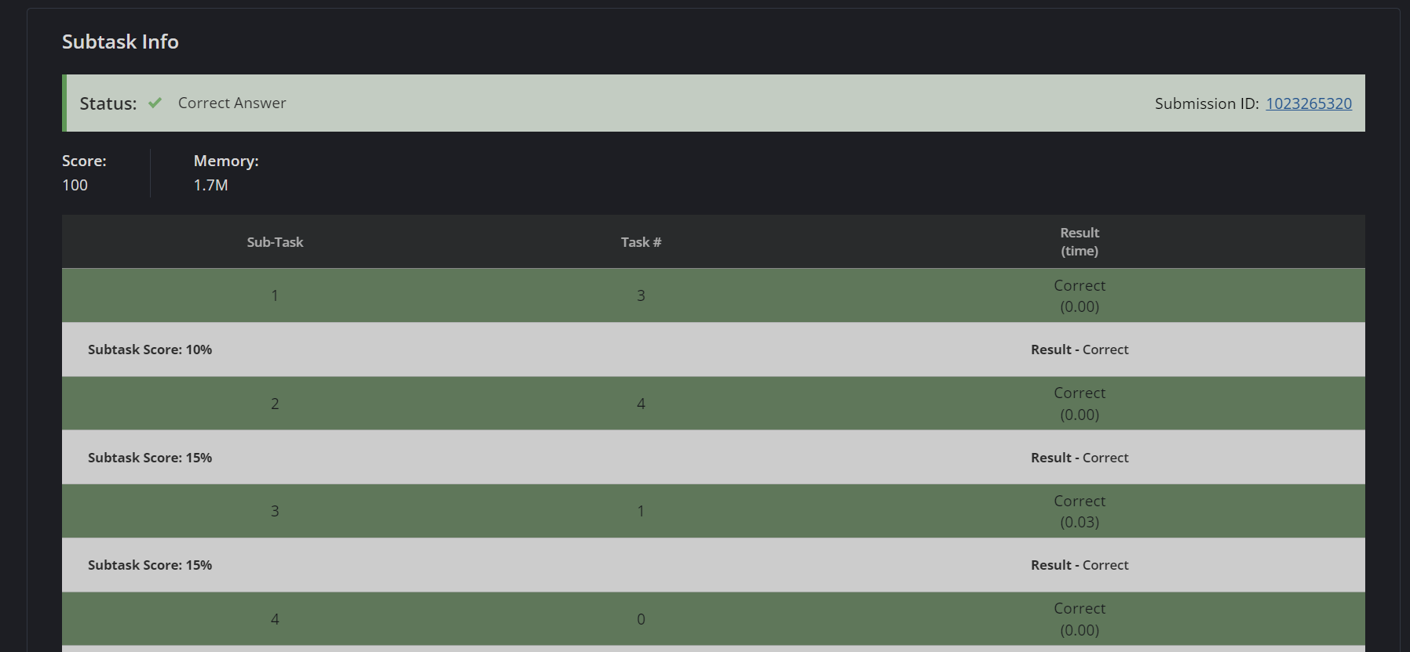

CODE FOR QUESTION 1:

#include <bits/stdc++.h>

using namespace std;

int main() {

int t;

cin>>t;

while(t--){

string s1,s2;

cin>>s1>>s2;

int l1 = s1.length();

int l2 = s2.length();

bool result = 1;

if(l1<l2 || l1%l2 != 0){

cout<<"NO"<<endl;

}

else{

sort(s1.begin(),s1.end());

sort(s2.begin(),s2.end());

int count = 0;

for(int i =0;i<l1;i++){

if(count == l2){

count = 0;

}

if(s1[i] != s2[count]){

result = 0;

break;

}

count ++;

}

if(result = 0){

cout<<"No"<<endl;

}

else{

cout<<"Yes"<<endl;

}

}

}

return 0;

}

CODE FOR QUESTION 2:

#include <iostream>

#include <math.h>

using namespace std;

int main() {

int N, K;

cin >> N >> K;

float y=0;

int ans=0;

y=log2(K);

ans=y-1;

cout<<ans<<endl;

return 0;

}

CODE FOR QUESTION 3:

#include <iostream>

#include<vector>

using namespace std;

int main() {

int t;

cin>>t;

vector<int>v;

for(int i=0;i<t;i++){

int x;

cin>>x;

v.push_back(x);

}

int count;

for(int i=0;i<t;i++){

count=0;

if(v[i]==1 || v[i]==2 || v[i] ||3){

count++;

}

}

if(count==t){

cout<<"No";

}

else{

cout<<"Yes";

}

// your code goes here

return 0;

}

CODE FOR QUESTION 4:

#include<iostream>

#include<math.h>

using namespace std;

int main(){

int t;

cin>>t;

float y=0;

for(int i=0;i<t;i++){

int x;

cin>>x;

y = log2(x);

}

cout<<ceil(abs(y))<<endl;

}

CODE FOR QUESTION 5:

#include<iostream>

#include<math.h>

using namespace std;

int main(){

int t;

cin>>t;

for(int i=0;i<t;i++){

int x,y;

cin>>x>>y;

}

int k;

cin>>k;

int c;

cin>>c;

int ans=k*c;

cout<<floor(ans)<<endl;

}

CODE FOR QUESTION 6:

#include <stdio.h>

int main(void) {

int t;

scanf("%d", &t);

while(t--){

int n, count = 0;

scanf("%d", &n);

int a[n];

for(int i = 0; i < n; i++)

scanf("%d", &a[i]);

int x, s;

scanf("%d %d", &x, &s);

for(int i = 0; i < n-1; i++){

for(int j = i+1; j < n; j++){

if((a[i]+a[j] == s) && ((a[i]^a[j]) == x)){

count++;

}

}

}

printf("%d\n", count);

}

return 0;

}